**Experiment Title:** Write a Python program to generate 26 text files named A.txt, B.txt, and so on up to Z.txt

**Student Name:** Parikshit sharma **UID:**19BCS4520

**Branch:** CSE IOT **Section/Group:** 1/A

**Semester:** 4 **Date of Performance:**13/04/2021

**Subject Name:**Programming in Python Lab **Subject Code:**CSP-287

1. **Overview of Virtual Box:**

Write a Python program to generate 26 text files named A.txt, B.txt, and so on up to Z.txt

1. **Tasks to be done:**

Generating 26 files named from A to Z using file handling.

**3. Steps for practical**: (Mention the steps for each and every task)

**Step 1:** Initialize a for loop in range from the ascii value of A to ascii value of Z+1.

**Step 2**: Inside for lopp use command to create a file using syntax

f=open("Destination"+name of file+".txt",'x')

**Step 3: End**

**Code:**

for i in range(65,91):

f=open("H:/WS 7/"+chr(i)+".txt",'x')

1. **Screenshots:**

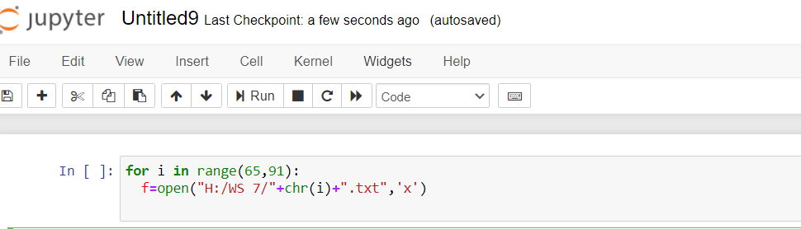

1. **Commands used:**

For loop

Open command in filehandling

1. **Result/Output/Writing Summary:**

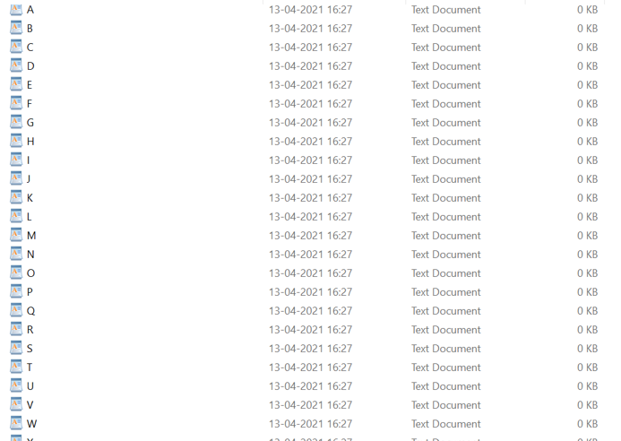

**Learning outcomes (What I have learnt):**

1. Learnt about the file handling in python.
2. Learnt about accessing files via python.
3. Enhance the knowledge of loops.

**Evaluation Grid (To be created as per the SOP and Assessment guidelines by the faculty):**

|  |  |  |  |
| --- | --- | --- | --- |
| Sr. No. | Parameters | Marks Obtained | Maximum Marks |
| 1. |  |  |  |
| 2. |  |  |  |
| 3. |  |  |  |
|  |  |  |  |